Alternatives to the deltopectoral approach: MIS and beyond!

EJ Harvey MD MSc FRCSC
Professor of Surgery McGill University

Goals for the Lecture
1 Learn alternative surgical approaches to humerus
2 Consider when to use a surgical approach
3

1 What was old is new again!

Percutaneous techniques

2 Lateral approaches- Safe? Better??
What does anatomy say?
What do the clinical outcomes dictate?

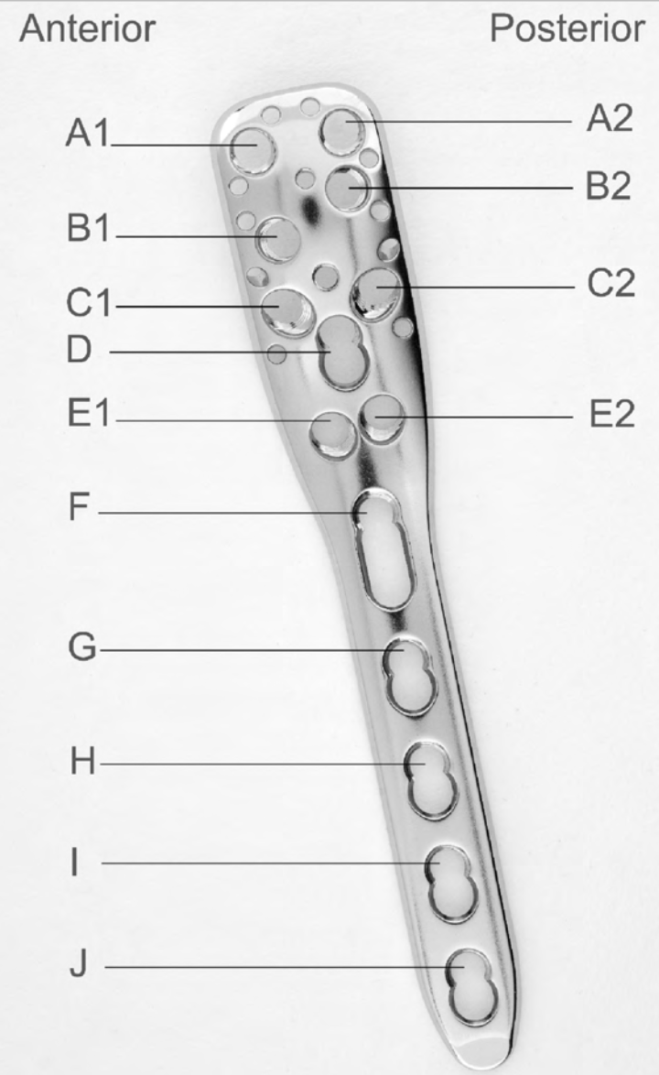

Notes

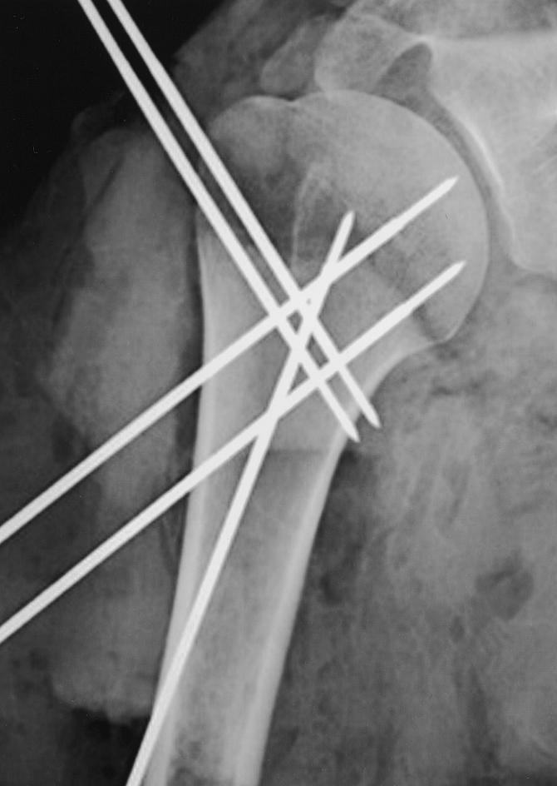

Calcar

Tuberosities

Neck

3 AVN
Do we care?
What to tell the patient

References

Int Orthop. 2016 Mar;40(3):579-85. doi: 10.1007/s00264-015-3069-z. Epub 2015 Dec 19.
Minimally invasive plate osteosynthesis in proximal humeral fractures: one-year results of a prospective multicenter study.
A consecutive series of 76 patients with proximal humeral fractures were treated with locking plate using a minimally invasive antero-lateral approach in two orthopaedic departments. Functional results with Constant score and radiographic evaluation were available for 74 patients at one-year follow up.
CONCLUSIONS: The MIPO technique for proximal humeral fractures was safe and reproducible for most common patterns of fracture. Major complication rate was apparently low due to a soft tissue sparing, deltoid muscle and circumflex vessels, with easy access of the bar area to correct positioning of the plate.

Int Orthop. 2012 Jun;36(6):1267-73. doi: 10.1007/s00264-011-1474-5. Epub 2012 Jan 18.
Percutaneous pinning of three- or four-part fractures of the proximal humerus in elderly patients in poor general condition: MIROS® versus traditional pinning.
The MIROS is a new percutaneous pinning device allowing correction of angular displacement and stable fixation of fracture fragments. A total of 31 patients treated with MIROS and 27 undergoing TPP were enrolled in the study. The MIROS resulted in better clinical results and less complications than TPP in elderly patients

Clin Orthop Relat Res. 2005 May;(434):123-9.
The extended anterolateral acromial approach allows minimally invasive access to the proximal humerus.
Twenty cadaver shoulders were dissected using the extended anterolateral acromial approach through the anterior deltoid raphe. Subsequently, this approach was used in 16 patients with proximal humerus fractures, none of whom has had complications related to the surgical approach. This minimally invasive surgical approach seems to be safe, and may be useful in treating proximal humerus fractures.

J Trauma. 2011 Dec;71(6):1737-44. doi: 10.1097/TA.0b013e31823f62e4.
Minimally invasive polyaxial locking plate fixation of proximal humeral fractures: a prospective study.
In a prospective study a cohort of 79 patients with 80 proximal humerus fractures were operated in a MIS procedure using a polyaxial locking plate. MIS surgery of displaced humeral head fractures can be performed in all types of humeral head fractures leading to low complication rates and good clinical outcome. A standardized stepwise procedure in fracture reduction and fixation is recommended to achieve reliable good results.

J Bone Joint Surg Am. 2001 Nov;83-A(11):1695-9.
Percutaneous pinning of the proximal part of the humerus. An anatomic study.
In ten fresh-frozen cadaveric shoulders, the intact proximal part of the humerus was pinned under fluoroscopic guidance with use of an identical published technique. The technique used in this study may be associated with a risk of injury to important anatomic structures about the shoulder. Lateral pins should be distal enough to avoid injury to the anterior branch of the axillary nerve, and multiple fluoroscopic views should be obtained to avoid penetration of the humeral head cartilage. There may be a risk of injury to the cephalic vein, the biceps tendon, and the musculocutaneous nerve with use of anterior pins, and these pins should be employed with caution. Greater tuberosity pins should be placed with the arm in external rotation, should be aimed for a point 20 mm from the inferior aspect of the humeral head, and should not overpenetrate the cortex.

